**Future Design Documentation**

The current version of the game includes a few levels that are chosen at random, phone menus, and the ability to seamlessly shift between the two states. Given more time, we would love to expand the game in multiple areas, including design more levels, including more choices, improving the overall coding structure, and adding more paths to lead the game to multiple conclusions based on probability and the choices the player has made.

Level Design

We would like to include more levels in the game. Currently, the space of possible levels the user will be confronted with is fairly small, but by adding more possible levels we can implement more complicated branching and add the variability of the player’s possible experiences. In terms of levels, we mean the combination of phone menus and platforming levels.

We would expand on the current platforming levels to make the challenges more difficult and include more of the elements common in traditional puzzle-platformers. In the figures below, you can see some of the level choices we have drafted for the first scene after the hospital.

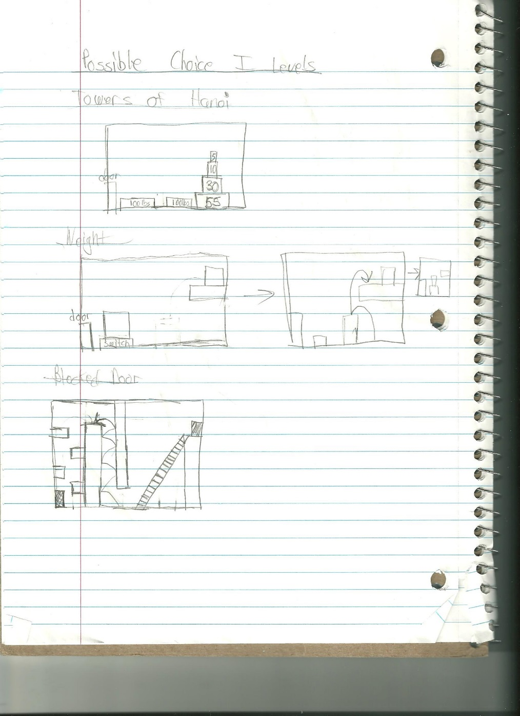

These levels include use of lifting (for boxes and the like) as well as switches and levers. By incorporating these dynamics more, we would make the game more of a mental task as well as a dexterity/skill based one. In addition, we would also add more difficult platforming challenges such as repeated wall jumping, crumbling tiles, and the like in order to keep the player on their toes.

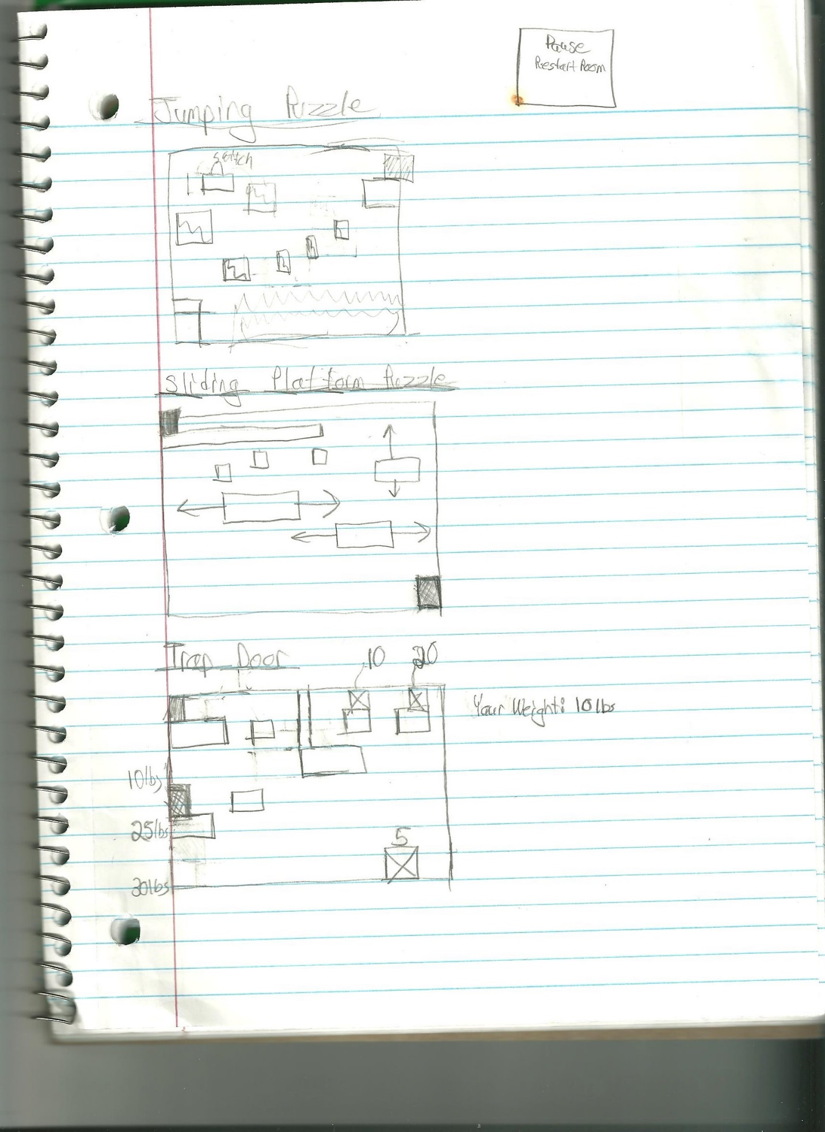

Choice Design

One of the most important themes of President Mystery is the aspect of choice. By allowing the player to confront the randomly generated scenario and make a decision based on their own intuition allows the story to branch off in multiple directions.

As seen in the diagrams below, the idea for the first level was to have multiple choices for the first platforming challenges that the player would be presented at random. The player would have the chance do one out of 2 selected challenges. Depending on their initial puzzles and the choices they made within those levels, the player would then be given two choices to make for determining their next destination.

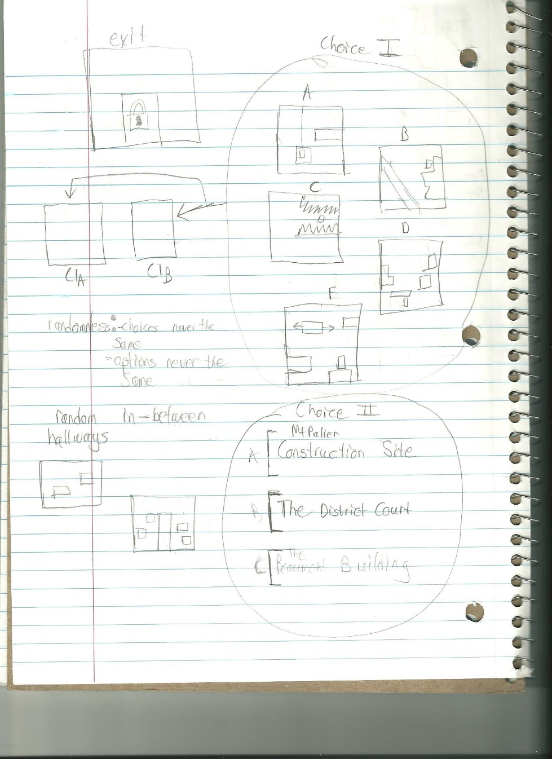

Below you cans see a few sketches on the possible effects of choice as well as an example of how different choices based on the levels given in the first stage would affect the later consequences in the game. This was meant to be a running theme, throughout the story up until the conclusion; every choice made would slightly impact the next presented choices and despite the random options presented, the player’s selection would be a deterministic driver for the plot.

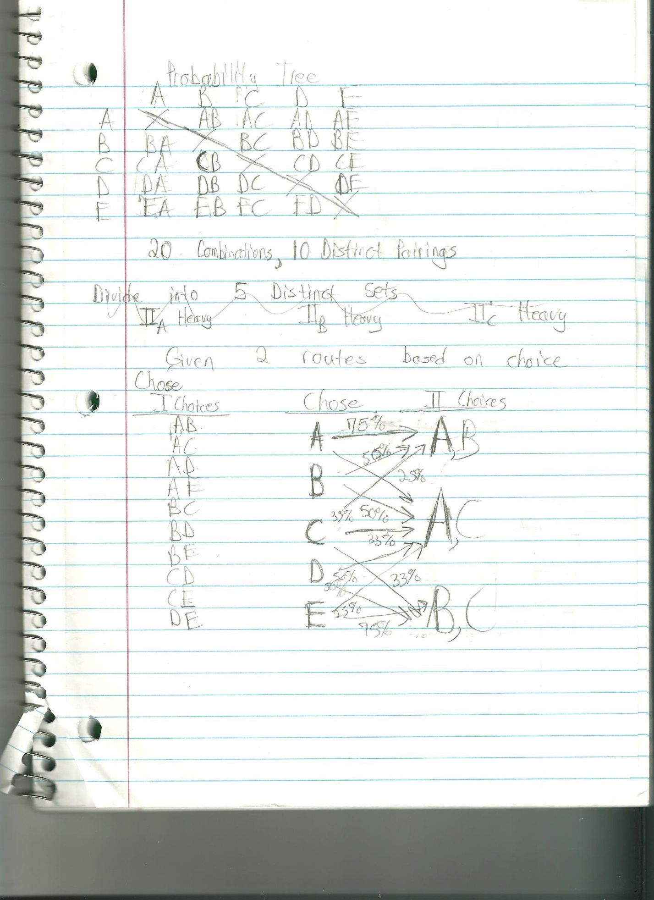

We also sketched out many possible endings spanning three broader categories of US in Chaos, US in peace, and US in ???, but in order to not spoil the plot they have been omitted.

Code Structure

In order to complete the design detailed above, we would look into improving our current code structure. We would need to make all of the components more modular, so that loading a level at random would be a simple task. We would need to create a plot tree that would keep track of the options a player has been presented with, the player’s choices, and the resulting scenarios that the game will generate based on those options.

We would like to expand on the Phone Menu to make it so that new states are created by loading saved text from a file or CSV instead of using separate screens.

Conclusion

Overall, there is a lot we would like to do to make President Mystery a complete game, but the current iteration does a great deal to reflect the plans we are hoping for.